In human beings, normal male has _______________sex chromosomes
A. XY
B. XX
C. XXY
D. None of these
ANSWER: A

In human beings, normal female has ____________sex chromosomes
A. XY
B. XX
C. XXY
D. None of these
ANSWER: B

Person suffering from color blindness find difficulty in distinguishing
A. Red from Green
B. Green from Orange
C. Yellow from Red
D. None of these
ANSWER: A

______________is a defect in which the blood fails to clot after an external or internal injury
A. Haemophilia
B. Color Blindness
C. Chromosomal Aberration
D. None of these
ANSWER: A

Hemophilia A is caused by a lack of blood clotting factor
A. VIII
B. IX
C. XI
D. None of these
ANSWER: A
Hemophilia B is caused by a lack of blood clotting factor
A. VIII
B. IX
C. XI
D. None of these
ANSWER: B
Hemophilia C is caused by a lack of blood clotting factor
A. VIII
B. IX
C. XI
D. None of these
ANSWER: C

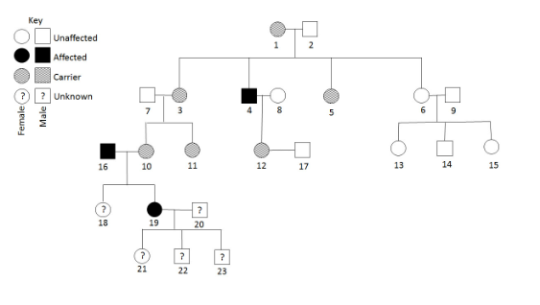
Consider the pedigree. What is the probability of individual 18 being neither affected nor a carrier?
A. 50%
B. 0%
C. 25%
D. 100%
ANSWER: B
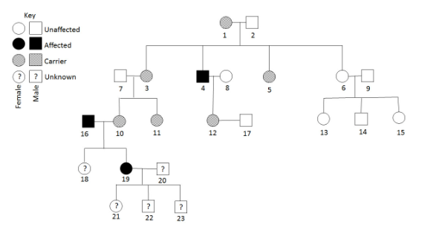
Consider the pedigree. If individuals 12 and 17 have a son, what is the probability of him being affected?
A. 25%
B. 50%
C. 0%
D. 100%
ANSWER: B
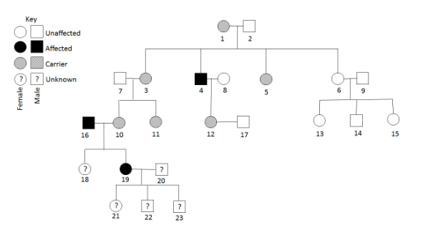
Consider the pedigree. If individual 20 is not affected, what is the probability individual 21 will be a carrier?
A. 25%
B. 100%
C. 50%
D. 0%
ANSWER: B
Red-green colorblindness is an X-linked recessive disorder. Jacob's paternal grandfather and father are both colorblind, but his mother has two normal alleles. What is the probability that Jacob is red-green colorblind?
A. 0%
B. 25%
C. 50%
D. 75%
ANSWER: A
Which of the following is inherited via an autosomal recessive allele?
A. Hemophilia
B. Color-blindness
C. Huntington’s disease
D. Cystic fibrosis
ANSWER: D
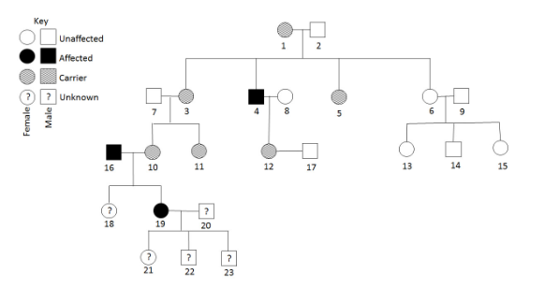
Consider the pedigree. What is the probability of individual 22 being affected?
A. 0%
B. 25%
C. 50%
D. 100%
ANSWER: D
Regarding colour blindness, “when a normal male marries carrier females’, which is the correct statement?
A. All daughters will be colour blind
B. All sons will be colour blind
C. All daughters are normal but carriers
D. Half of the sons will be colour blind
ANSWER: D
Persons suffering from color blindness has difficulty in distinguish:
A. Blue from green
B. Red from purple
C. Yellow from green
D. Red from green
ANSWER: D

